Contact: Jamie Schwarz For Immediate Release
Tel: 513-770-4200
Mobile: 919-323-7473
Email: jamie@cncindexing.com
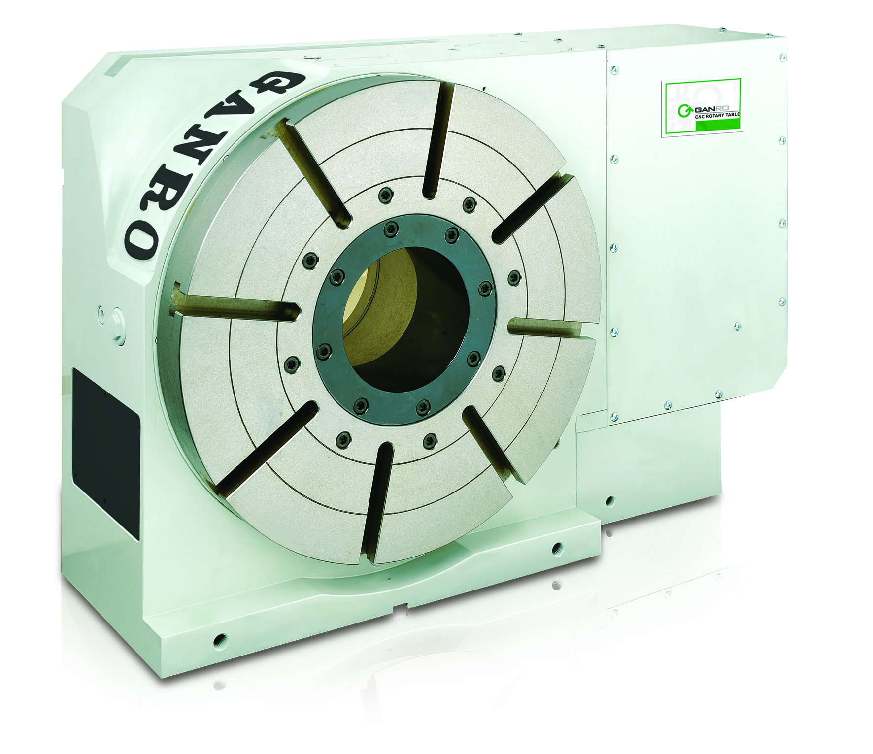

CNC INDEXING INTRODUCES GANRO DR SERIES ROTARY TABLES

Mason, Ohio – September 28, 2012 - Ganro Industrial Corporation, formally known as Golden Sun Industrial, has introduced their new DR Series model of rotary tables and indexers.

Their new series of rotary tables and indexers range in faceplate diameter size from 120mm (4.72”) to 2,500mm (98.42”). The vast range of available sizes accommodates the majority of manufacturer’s requirements. All DR Series rotary tables can be utilized in the vertical or horizontal position to increase manufacturing flexibility.

The DR Series features a more compact base which uses less of the machining envelope allowing more machine table space for workpieces and additional workholding equipment. All Ganro rotary tables are now standard with larger center thru-holes to accommodate larger workpieces.

Internally the new design features a new deeper double lead worm system. This improved worm shaft and worm wheel design will increase accuracy and reduce backlash giving users the ability to produce better workpieces. The new design also features improved gear ratios for increased rpm’s.

CNC Indexing & Feeding Technologies is the exclusive importer/reseller of the complete line of Ganro products which includes horizontal and vertical rotary tables, indexers, tilt rotary tables and associated accessories. CNC Indexing stocks the most popular Ganro models, accessories and parts at their Mason, OH location. In addition, full installation and repair services are offered.

CNC Indexing also produces high pressure coolant systems and imports bar feeders and oil skimmers. You can obtain more information on the products offered by CNC Indexing & Feeding Technologies on the internet at www.cncindexing.com or by calling 513-770-4200.

###

